Banking Platform
Stored Structures

Sobika .E
29/6/2026
This PL/SQL program defines procedures to automate key banking operations such as applying monthly interest to savings accounts, updating employee bonuses by department, and securely transferring funds between accounts.

Objective:
- Apply Monthly Interest: Calculate and update a 1% interest on all savings account balances.
- Update Employee Bonuses: Increase salaries of employees in a specified department based on a given bonus percentage.
- Transfer Funds Securely: Ensure safe transfer of funds between two accounts with sufficient balance checks.

Implementation
First Create a Table for Accounts and Employees and Insert the values into it.

Scenario 1:
Apply 1% interest to all SAVINGS account balances.

CREATE OR REPLACE PROCEDURE ProcessMonthlyInterest AS
BEGIN
UPDATE ACCOUNTS
SET BALANCE = BALANCE + (BALANCE * 0.01)
WHERE ACCOUNT_TYPE = 'SAVINGS';
DBMS_OUTPUT.PUT_LINE('Monthly interest processed for all savings accounts.');
COMMIT;
END;
/

To run this process,
BEGIN
ProcessMonthlyInterest;
END;
/

Scenario 2:
Give bonus percentage (parameter) to employees of a specific department

CREATE OR REPLACE PROCEDURE UpdateEmployeeBonus(
dept_id IN NUMBER,
bonus_percent IN NUMBER
) AS
BEGIN
UPDATE EMPLOYEES
SET SALARY = SALARY + (SALARY * bonus_percent / 100)
WHERE DEPARTMENT_ID = dept_id;

DBMS_OUTPUT.PUT_LINE('Bonus applied to department: ' || dept_id);
COMMIT;
END;
/

To run this process,
BEGIN
UpdateEmployeeBonus(101, 10);
END;
/
Scenario 3:
Move amount from one account to another, only if balance is sufficient.

CREATE OR REPLACE PROCEDURE TransferFunds(
from_acc_id IN NUMBER,
to_acc_id IN NUMBER,
amount IN NUMBER
) AS
from_balance ACCOUNTS.BALANCE%TYPE;
BEGIN
-- Check balance
SELECT BALANCE INTO from_balance
FROM ACCOUNTS
WHERE ACCOUNT_ID = from_acc_id;

IF from_balance < amount THEN
RAISE_APPLICATION_ERROR(-20001, 'Insufficient balance in source account.');
END IF;

-- Debit source account
UPDATE ACCOUNTS
SET BALANCE = BALANCE - amount
WHERE ACCOUNT_ID = from_acc_id;

-- Credit destination account
UPDATE ACCOUNTS
SET BALANCE = BALANCE + amount
WHERE ACCOUNT_ID = to_acc_id;

DBMS_OUTPUT.PUT_LINE('Transferred ₹' || amount || ' from Account ' || from_acc_id || ' to Account ' || to_acc_id);
COMMIT;
END;
/

To run this process,
BEGIN
TransferFunds(1001, 1002, 500);
END;
/

Output:
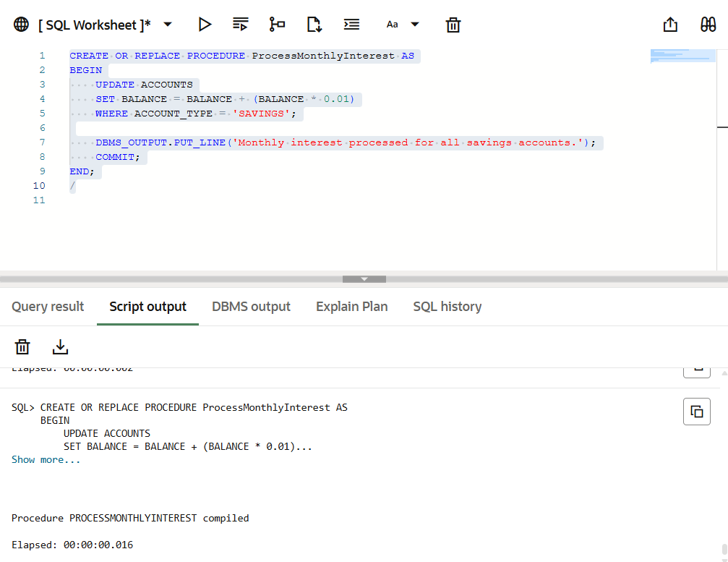

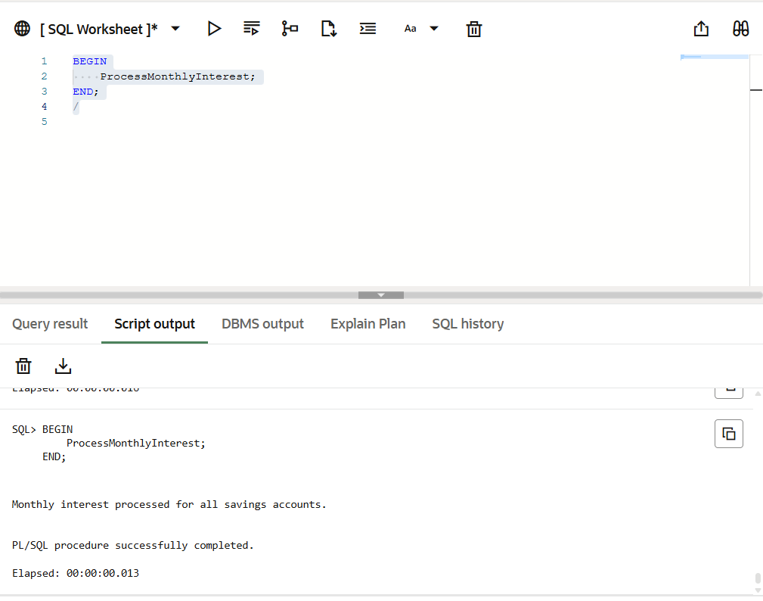
Asd
